# How to use NutrientAPI for Nutrient APP?

## General Note

We have strictly followed the Nutrient App API References, so only supporting information  is provided below. Response message, Data type all are checked according to the API reference manual.

## Get All samples Info of nitrate or phosphate type

In order to get samples of nitrate or phosphate type,  you have to send request from your application with your desired sample type[see below]. In the response, you will find all the existing samples of a particular category. Below are some example requests for getting samples.

<https://gwf-nutrient.usask.ca/api/v1/samples?type=nitrate> //request type get

<https://gwf-nutrient.usask.ca/api/v1/samples?type=phosphate> //request type get

## Collect Sample Data

For saving a new sample, app has to send a post request to the server using the URL given below. Parameters need to be prepared in a JSON format for the url. As described previously in the Nutrient App API References Doc,  three parameters [color_method, color_correction, temperature] are optional for a specific request. However, required missing parameter will generate a JSON response by mentioning the missing parameter name for convenient debugging.

<https://gwf-nutrient.usask.ca/api/v1/samples/collect_data>  //request type post

Sample JSON format for the above post request.

{

"latitude": "52.164312",

"longitude": "-115.164312",

"type": "nitrate",

"reference_measurements": [ 215, 42, 108, 224, 96, 144, 215, 121, 147, 214, 135, 154, 211, 166, 161, 205, 185, 178, 209, 185, 161 ],

 "measurement": [ 214,181,176, 214,181,176, 214,181,176, 214,181,176 214,181,176, 214,181,176, 214,181,176, 214,181,176, 214,181,176],

  "color_method": 1,

   "color_correction": “1.25”,

   "mass_concentration": "3.12",

    "light_condition": 5,

    "origin_of_water": "Well",

     "at_sampling_location": true,

      "temperature": "29.3"

       }

## POSTMAN- Testing the post request API

1. In order to send post request, you have to use POSTMAN application. First, you have to create a new request similar to the figure.

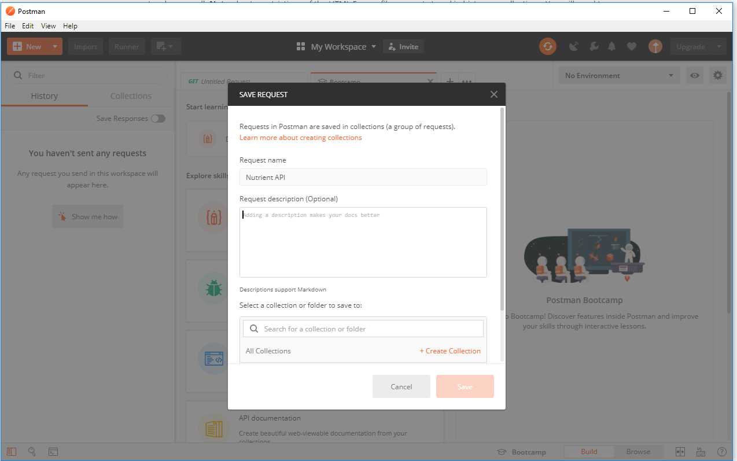

1. For sending post request, you have to select post from the method tab and enter the url. Next, as you have to send JSON data with your request, you have to go to the body tab, then select raw and JSON application type. Now, you have to paste the JSON data similar to the below figure.
2. Pressing the send button will give you the response from API server.

